

ade lab simulation

Asynchronous Up Counter Simulation



by :

MoHAMMED YAHYA

uSN : 3PD23CS076

SAINATH PATIL

USN : 3PD23CS120

SEC : B

**Aim** : To display 3 bit binary digits from 0 to 7 using asynchronous up counter

**Theory** : 3 bit asynchronous counter can be made by using sequential circuit of 3 T flip-flop then 3-bit binary number can be displayed by 7-segment display by using BCD decoder

**Circuit Diagram:** 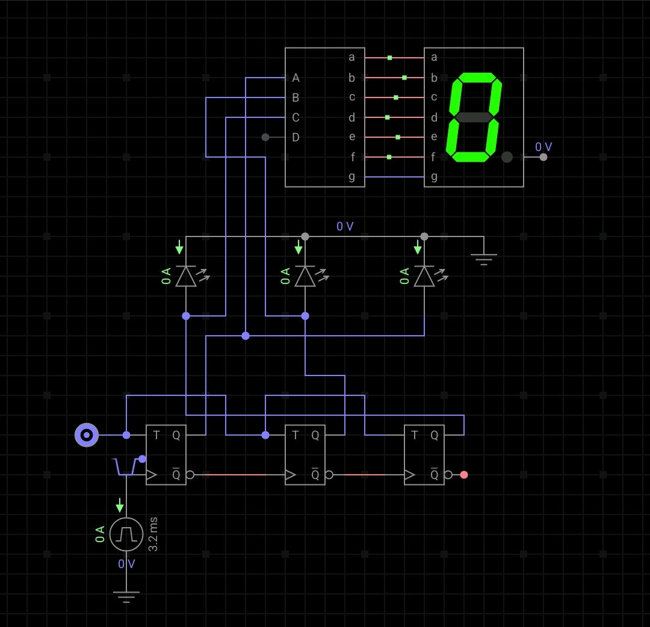

**Truth Table** :

Asynchronous counter :

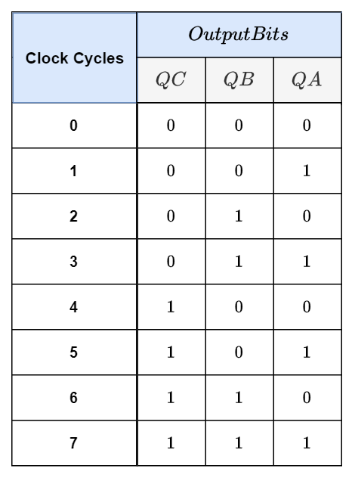

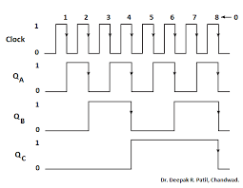

The binary output from the 3 bit asynchronous counter is given as input to BCD converter and it is displayed by 7 segment display as shown

**BCD 7 segment decoder**:

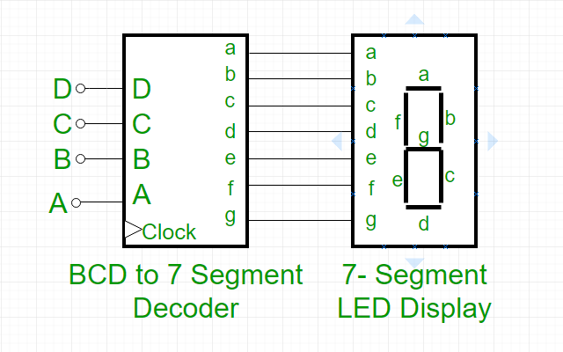

**Final output** :

